Landmark Theatres Work Experience Pack

Landmark Theatres is an organisation that runs two theatres in Peterborough, the Key Theatre and the New Theatre. We are always looking for ways to collaborate with young people and know that work experience is a great opportunity for us to give local students an insight into how we operate!

This pack is designed to let you know a little about us and what our work experience offer is. If you have any further enquiries, or would like to arrange a conversation to discuss work experience with us, please contact our Education Officer Joanna at joanna.linford@landmarktheatres.co.uk

Included in this application pack is information about:

- Our Venues
- Our Departments
- What Our Work Experience Offer Includes
- What We’re Looking For
- How to Apply
- What Happens Next
Our Venues

The New Theatre
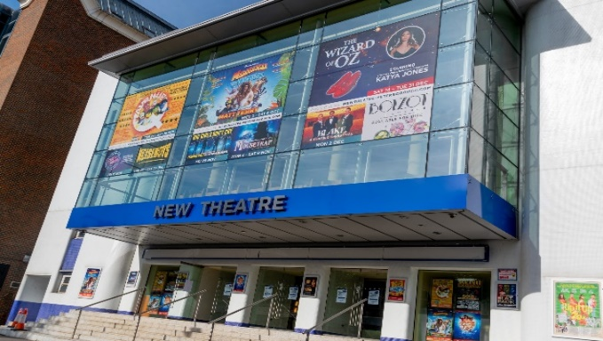
The New Theatre Peterborough is a beautifully refurbished venue with 1079 very comfortable cinema-style seats.
The venue attracts top name acts and large scale touring productions to perform on its vast, newly improved, stage. Conveniently located just a short walk from Peterborough centre, bringing the best live entertainment to the city.
www.newtheatre-peterborough.com
The Key Theatre

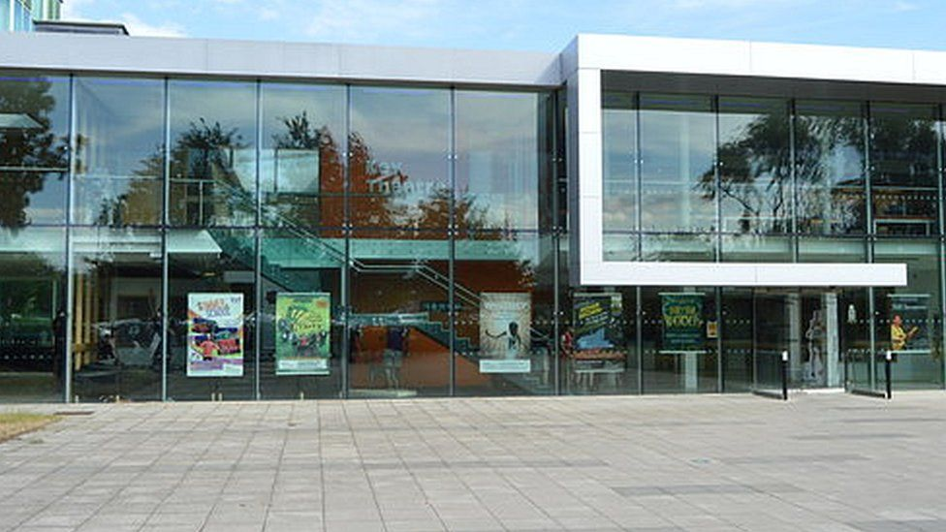
The Key Theatre in Peterborough is a modern glass-fronted cultural and entertainment venue with a 360 seat auditorium and 94 seat studio. We also have 3 rehearsal rooms that are often used for local theatre, dance and community classes.
www.keytheatre-peterborough.com

Our Departments

Like all successful theatres, we have various departments that work daily to ensure that everyone has the best experience whilst with us. A lot of stuff goes on behind the scenes and there’s always something to be done.

Taking part in our work experience programme would mean getting a snippet of each department, to allow you a well-rounded opportunity in the hope that you’d walk away with a brand new appreciation and understanding of all that it takes to work in a thriving city theatre.

It is our aim that all successful work experience applicants will take part (in some capacity) in activities from each of the following departments.

Operations
The Operations team deal with all things practical and organisational. Think, making sure the correct staff are in the building to help set up shows, that we have enough stock, that all our takings are accounted for and making sure the venues are opened and closed at the correct time.

Programming
The Programming department are the people who book the shows and negotiate a deal with touring company’s and hirers. They need to have a keen eye and a fantastic understanding of what will be popular to bring to one of our Peterborough venues.

Production
The production team consits of many in house and freelance creatives including directors, choreographers and producers. Production are the people who develop and put together some of the amazing shows at our venues.

Tech
The Tech department make our shows look amazing. From stage design, to sound, to lighting and all the practicalities that come with making a performance come to life! The Tech team work with the shows we host to build their stage and are a crucial part to any show you watch at one of our venues.

Marketing
Once a show is booked in, we’ve got to spread the word. This is where the Marketing department comes in. From creating daily posts on social media, to writing press releases, to keeping our websites up to date, the Marketing team are always busy making sure everyone knows all about the exciting shows and opportunities we have coming up.

Box Office
None of the work we do would be possible without the work put in by our Box Office department. They’re the first ones you see when you enter the building and the ones who guide you through your booking, being there to answer the phone or deal with any queries or requests from customers or hirers.

Administration
The Administration department deals with all the details. From ensuring that invoices and show settlements are arranged and processed, to making sure there is enough stationary in the office cupboard, there’s always an admin task to make sure our venues are running as efficiently as possible.

Talent and Participation (T&P)
The T&P department is all about broadening what we host beyond just ticketed shows, aiming to develop opportunities for local people, be that creative, professional or experience based. The Participation team work to get as many people involved in all that we have going on and are always on the lookout for new and innovative ways to make our venues better for all.

What our Work Experience Offer Includes

Each successful work experience applicant will:

- Take part in a scheduled week of planned activities in each of our departments from Tuesday 27th May – Saturday 31st May 2025 (May half term).
- Work alongside a team of helpful professionals.
- Each successful work experience applicant will take part in a guided mock interview to prepare you for your next job interview.This is completely informal and a chance for you to ask questions and recieve coaching on how to make a great impression when interviewing for work in the future.
- Have fun… we hope!
What We’re Looking For

This work experience placement is perfect for those studying creative, technical or business based subjects. Or for those interested in having a career in management, tech, marketing, hospitality, or something within a creative industry.

Desirable attributes would be:

- Confidence to communicate well with others.
- Curiosity to ask questions about the way we operate.
- A good listener, who knows how to put what they have learnt into practice.
Although these may be our desired applicants, we are open to anyone with the correct attitude, drive and ambition.

How to Apply
If this sounds like something you’d like to get involved with, then we’d love to hear from you. The application form is available on our website. Alternativly email our Education Officer Joanna at joanna.linford@landmarktheatres.co.uk or our Talent and Participation Manager, George at george.barnett@landmarktheatres.co.uk to request an application form. The closing date for applications will be 3rd March 2025.

If you’re unsure how to fill out our application form or require additional assistance, we’d advise joining us for our free to attend Work Experience Application Writing Session on Monday 17th February 2025 - for more information please visit our website.

Next Steps

Once you’ve submitted your application form, you will be invited to attend an hour-long workshop at the Key Theatre on either Monday 31st March or Friday 4th April 2025.

Important Workshop Information:
- Places will be allocated on a first come, first serve basis, so please complete and return your application as soon as possible. If you have booked a space on our Work Experience Application Writing Session, we will ensure a workshop space is reserved for you.
- A workshop invitation does not guarantee you a place on the work experience week.
- Although this is not an interview, due to the volume of applications we receive, we will need to be selective with who we choose for this year’s cohort, so please come prepared to join in and show us why you’re the right candidate for this opportunity.

We look forward to hearing from you soon!

